Debrief on the 2010 derby

These are just quick notes from the meetings on 8/18 and 8/19 with suggestion of how to improve the race in future years. If I get a chance I might organize them and put them in a format that makes sense.

Biggest complaint was that the race got started late and a had a lot of dead time; it took way too long to determine next race, get the car in place and load the ramp.

Changes to implement for 2011 and beyond
Early registration: All racers and cars must be registered by the Monday before the race. Put this in CAPITAL LETTERS in the rules. By the time we start we have to know what the first heat of races in every class are. We have already run through the possibilities and running the cars around to accommodate races that might occur as the brackets tighten.
Contact the racers individually by phone;
Start inspecting at 5:00 pm; Flag ceremony at 5:50; First race at 6:00 sharp

Better flow of racers as they come in to tech; formalize locations of everything and make sure drivers know when they come in where they need to be. instruction cards so they know what to do (in lieu of drivers' meeting) with diagram of flow, instructions for flag ceremony (line up cars on the track diagonally, pit steward to oversee so the first cars to race are lined up at the front) stand by your car.

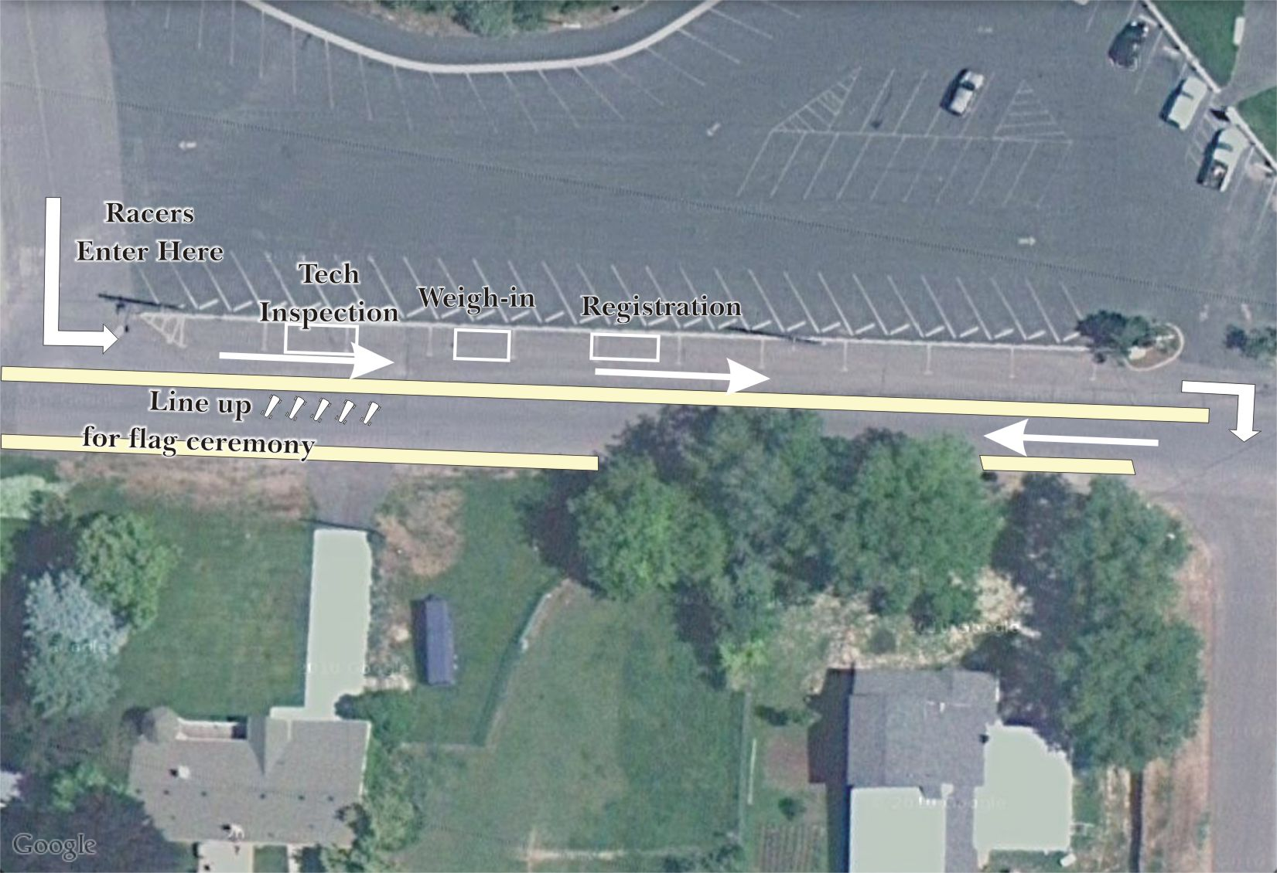

Four stations of people doing tech/registration.
1) tech inspector, checks for safety and compliance, need a very comprehensive checklist including all the problems we've seen over the years (may have 2 inspectors doing this),
2) weigh tech, verifies that the car meets weight for its class. Gives inspection sticker (tech has already signed off on the rest of the car)
3) recorder, takes leader card, takes and checks inspection sheet, issues name tag (already printed because everyone's already registered),
4) Pit steward checks that each racer has a name tag, signifying that they are completely registered and ready

Move weigh-in and inspection to other side of the fence? Downside: uses up parking spaces.

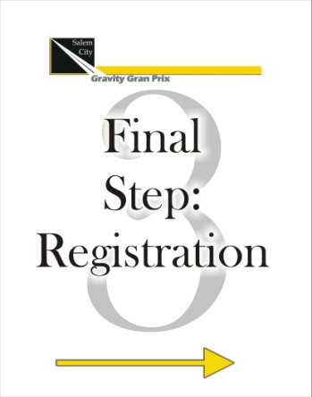

Go through all of this with the staff at the early inspection the week before the race.

Better flow of racers in general.
A lot of this is addressed with early registration so that we have things outlined beforehand. It can be sped up by running the brackets by computer; not done this year because of the bother of a car battery and inverter to run the laptop and I had too many other things to do. With a dedicated recorder's trailer that has all of that built in, this problem will be addressed.
The Spreadsheet on the laptop assigns the lanes so that delay is eliminate. Three systems will be in use: Leaderboard, manual brackets, and computer brackets. They should all look the same.
The leaderboard is designed to duplicate tournament brackets. A race can be run entirely with the leaderboard tower. All cards start to the right of the board. That represent the column of competitors at the very beginning (left side) of a tournament bracket. Cards of racers that lose, move left. The left column on the tower is the same thing as the loser's bracket on the lower part of a tournament bracket. A second loss and the card moves left off the tower. Racers will group as they do on the bracket (racer in one slot competes with racer in the slot just below).
The computerized brackets just automatically move the racers as they win and lose. The manual sheet is a backup of the computer, because anyone who depends on a computer is in for a big heartbreak.

Cars must have a unique number and it must be displayed on the car so the recorder can see it (left side of the car). Discussed having an assigned number for the race like runners do and you can paint any number on the car (or no number at all). This might need to be implemented when we go county-wide with a racing association because it's easier to keep unique numbers in a smaller group.

Have to have a dedicated pit steward, that's all he does, lines up which cars are to race next, and next and next. This guy cannot have ADD. For two hours all he does is communicate with the recorder and find cars and drivers and get them in place for the ramp loaders.

Any one car can only have one racer in any one class. We tried to accommodate more people this year by timing runs when two drivers with the same car were slated to race each other, but it introduces a complexity we don't want to deal with.

All races in any one division, including the championships, are completed before we start the next division. This will result in a slight delay when the brackets tighten and cars that have just raced have to get to the top of the track for the next race, but it will make the ballast issue much simpler. Having the Rhinos run up outside the track will lessen the delay.

Communication top to bottom
Radios on the same frequency with fresh batteries that have been tested. This has been a perennial problem. We have to have someone (other than me) in charge of testing the radios, putting fresh batteries in them, and getting them to the track. They've been at the track every single year and they've never once worked.
Possibility: Online meeting so the pit steward's laptop at the top of the track sees the recorder's screen

New ramp.
New ramp will load from the back. Independent tilt decks on the back have channels for the wheels. Loaders push cars up the ramp, then lock the stop in place. A scale integral to the stop will read the weight (adjusted for ramp angle) of the car. The loader immediately knows if the car is within weight. He can pull a car off the scale to fix a problem without affecting the other cars on the ramp. Once a car is okayed, the back loading ramp is tilted level. Chocks prevent the front wheels from rolling.
The front deck also tilts. Once racers are released, it is tilted level to load the waiting cars on the back of the ramp. They roll forward to the releases, which are up. Safety latches prevent the ramp from being tilted level without the release posts raised.
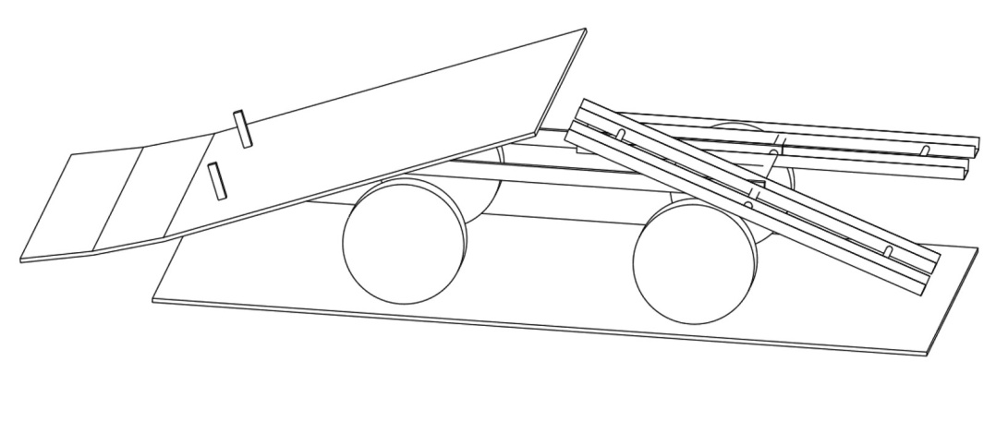
The leading edge of the ramp does not tilt back with the tilt deck. It has been contoured to the shape of the road for the first couple of feet of the ramp. Lightly loaded sand bags under orthopedic sand bags provide the transition to the road surface under the static part of the transition deck. The front portion also has a lower angle than the rest of the deck, so the car has a transition from the release deck to the road surface. The front lip of the release deck tilts into a mating recess in the transition deck so that it has a flush fit every time.

The ramp man on the left side of the ramp has to activate a safety release before the ramp man on the right triggers the release, so no cars can run until both workers are in agreement that it is ready.
Ramp crew consists of four loaders, two front and two back. One loader might be able to work the back alone, since the decks are independent, but it would be a lot of work.
The goal is to get as many racers down the track as possible in the shortest possible time.
The ramp will be just over 8' wide for transport and will fold out to 14' wide for racing. This puts 5' between the cars on the ramp. The back ramps will probably fold up and inward, aircraft carrier style. That may be the best way to do the front ramps as well, but a suggestion was made that the outer panels just plug into sockets like a trailer hitch receiver. The released on the front ramp will be on 8' center so they don't have to fold up with the wings.

Incorporating pivots and wings makes a fairly complex ramp, but it has to be done for faster loading and ability to transport the ramp when we go county-wide.

Barricades
The City mandated straw bales down both sides of the road this year. Then they were upset at the mess it made and outlawed it for future races. They suggested using water barrels and snow fencing (like we've done in the past) but we don't know how cars react when they hit snow fencing—we've never had a car tag the barrier. The mayor suggest silt fencing.
Silt fencing eliminates the concern about snagging on the snow fencing, it's cheap, it's strong. We would anchor it to water barrels spaced at intervals along the race course. We can put bundles (3-5) barrels of water at the end of intervals, held with cargo straps to tension the barrier between. We can run a parachute strap at about 10" (3/4 of wheel height) stretched between to help catch cars. We need a barrier that cars won't go over and can't go under so no one gets clotheslined by a strap or cable. Neways has a lot of water barrels we can probably use.

A possible alternative was suggested: irrigation pipe (10" diameter or so), but it's expensive, too. Could hold in place with sand bags.
Water barricades would be the ideal solution, but for some reason no one wants to spend the $10,000 it would cost to buy them.

In future years we will shift the whole track south as far as we can to get better pavement and allow the Rhinos access.
We'll have a wider ramp next year, so some of that benefit will be negated.

Rhinos
Must run up outside the track; they couldn't this year because of straw. The course was completely lined. If they can run past the course to the back of the ramp the problem is solved, but the area gets constricted at the at point. With a silt fence barrier maybe we can incorporate a gate they can pass through that they couldn't do this year with bales of straw.

Should we require a hook on the cars for the Rhinos to attach to? The tow bar should have PVC pipe over the tow strap so cars stop when the Rhino stops, and can't run over the tow strap. We had an incident this year where a dad got excited and told the Rhino driver to stop when his son's car ran over the strap, and the other car ran into the tow bar and broke up its front.

Early inspection
We want to close road for the early inspection date so that cars can run off the ramp. The early inspection gives the builder plenty of time to make sure his car is safe. We had one car this year that we shouldn't have allowed to race because of a very dodgy steering fix. I did a very bad thing and let him race, but if the steering had failed it would have permanently cancelled the derby for everyone forever. Fortunately it didn’t fail, but we have to find those problems early so he can fix it in time for the race. If he shows up to the track on race day with a dangerous car we can't allow him to race. We have an increasing database of what to look for, and if we specifically spell things out in the rules (no pressed wood or masonite in the steering; no screw-in eyelets) they can't argue with the tech inspector about whether it's a violation of the rules or not.

County Racing Association
We discussed races in other cities with their festivals.

We want to start up a Utah Valley Gravity Gran Prix Association. Every city would have a local soap box derby during their Summer festival.

Steel Days, American Fork
Fiesta Days, Spanish Fork
Mapleton 24th Celebration
Orchard Days, Santaquin
Salem Days
Onion Days, Payson

All members of the association would follow the same basic rules for car design so that cars from any city can race in any other city. We'd use the same ramp, scales, etc., since we already have them built.

The winners from each city would race in a championship at the end of the city and we'd have an awards banquet for everyone.

People go to all the trouble to build a car (or multiple cars) then they get to run them for two hours/year. Same thing with the ramp and scales. We're going to build an extreme ramp now and a recorder trailer for a desk, storage, and scoring tower. It should get more use than two hours/year.

If we have races in other cities the racers will have more than one chance. If the car's not ready for one race he can enter it in the next one. By the end of the season he should have the kinks worked out pretty well.

Other issues:
Sound system didn't reach people sitting up the track or down the track from the speakers. Part of the problem was the wind this year (we'll ask the City what they can do about that) but in the future we need speakers along whole length of the track.

City will provide Safety vests for all our workers—ramp loaders, pit steward, recorder, probably even the official photographer and videographer.

We need to have trash cans, one by the announcer's stand, one at the top of the ramp an Igloo cooler with Gatorade mixed and paper cups for the racers and workers.

Move dumpster. For some reason a giant dumpster was by the entrance to the track and blocked the view of people as well as being somewhat of a hazard.

